A Way to Pentecost
A Novena from Ascension to Pentecost

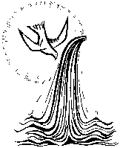
Introduction

After the Ascension, we are told that the disciples returned to Jerusalem and spent time together in prayer. They probably also shared stories of things they had seen Jesus do - the things they had heard people say.
Over the next nine days, we will use the Gospel of each day as a starting point as a time of prayer. The format is designed to be flexible - for you to use as much or as little as you wish in our journey towards Pentecost.
The outline for each day is similar:
Reading: from ...
Usually a short extract from the day's Gospel but with reference to the full text.
Wondering
A few questions that might be sparked from the reading.
Contemplating
Either lectio divina - the slow, prayerful reading of Scripture.
or
Idea using the imagination or idea for a time of quiet prayer.

Reflecting
Thoughts - questions and intentions for prayer.

Praying
A prayer invoking the Holy Spirit.

Action Point
A thought to take into the day from Pope Francis.

From the Sequence for Pentecost
Over the nine days, we will pray the whole Sequence in readiness for Pentecost Sunday.
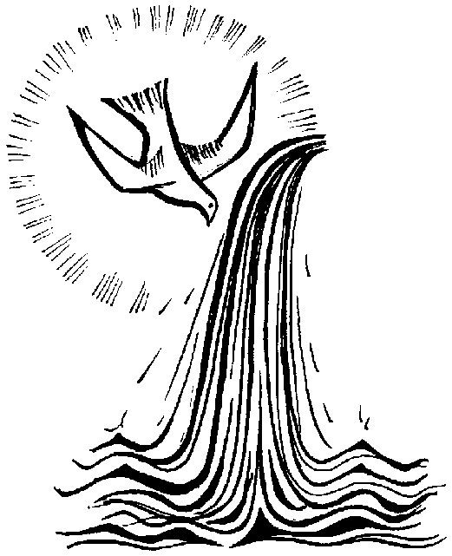
Our Father… Hail Mary… Glory be...

